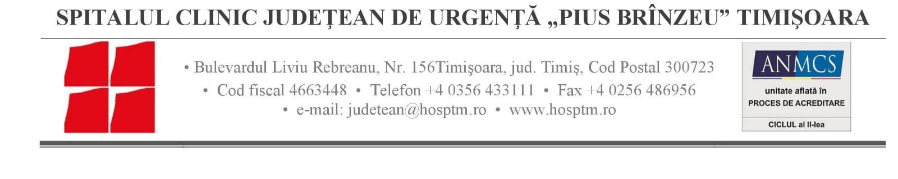
SUPPLIES CONTRACT AWARD NOTICE
TITLE Procurement Specific laboratory reagents for the project “Romania-Serbia joint initiative against cancer in cross-border region: improved diagnosis and treatment of malignant tumors – ROSECAN”
Location - Timisoara city, Timis County, Romania,

1. Type of procedure

Local open tender procedure

2. Publication reference and date of the contract notice

RORS-193/1/2022 and 02.02.2022

3. Lot number and lot title

LOT no 2 - Reagents for molecular biology

LOT no 8 – Reagents for next generation gene sequencing (NGS)

LOT no 9 – Supplies for next generation gene sequencing (NGS)

4. Contract number and value
No. 1108, Amount: 55.999,79 EUR

5. Date of award of the contract

02.05.2022

6. Number of tenders received

LOT no 2 – one

LOT no 8 – one

LOT no 9 – one

7. Name, address and nationality of successful tenderer
SC ANTISEL RO SRL, Bucharest, no 12, Budila street
8. Duration of contract
1 month
9. Contracting Authority
"PIUS BRÎNZEU" EMERGENCY COUNTY CLINICAL HOSPITAL TIMISOARA
10. Legal basis
Regulation (EU) N°236/2014 of the European Parliament and of the Council of 11 March 2014 laying down common rules and procedures for the implementation of the Union's instruments for financing external action
COUNCIL REGULATION (EC) No 1085/2006 of 17 July 2006 establishing an Instrument for Pre-Accession Assistance (IPA)
REGULATION (EU, EURATOM) No 966/2012 OF THE EUROPEAN PARLIAMENT AND OF THE COUNCIL of 25 October 2012 on the financial rules applicable to the general budget of the Union and repealing Council Regulation (EC, Euratom) No 1605/2002
COMMISSION DELEGATED REGULATION (EU) No 1268/2012 of 29 October 2012 on the rules of application of Regulation (EU, Euratom) No 966/2012 of the European Parliament and of the Council on the financial rules applicable to the general budget of the Union
Practical Guide to Contract procedures for EU external actions published on the EuropeAid
http://ec.europa.eu/europeaid/prag/previousVersions/document.do?num=2015.0&lang=en
http://ec.europa.eu/europeaid/prag/previousVersions/annex.do?num=2015.0&lang=en

